Lab 2

Self Practice Activity Solutions

Tasks: Use terminal for following tasks.

1. Create a directory and then create a text file, add some text content.

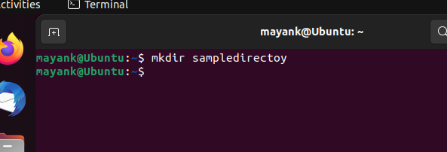

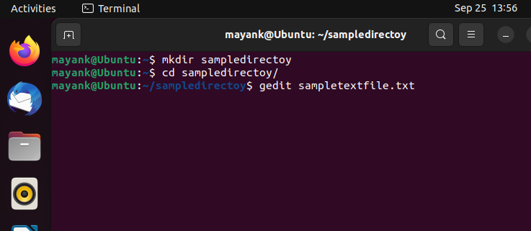

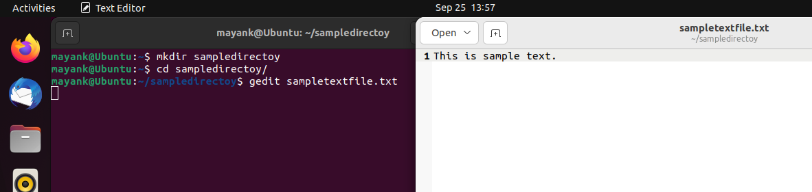

2. Move that file to Desktop.

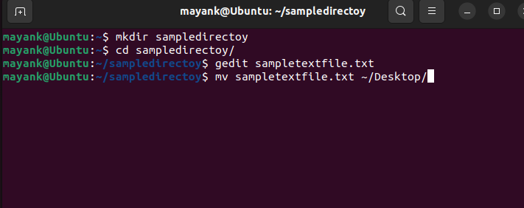

3. Remove the created directory.

